**LAPORAN TUGAS KECIL 3**

**IF2211/Strategi Algoritma**

**Semester II Tahun 2020/2021**

Dipersiapkan oleh:

|  |  |
| --- | --- |
| Fakhri Nail Wibowo | 13519035 |
| Dwianditya Hanif Raharjanto | 13519125 |

Sekolah Teknik Elektro dan Informatika - Institut Teknologi Bandung

Jl. Ganesha 10, Bandung 40132

**Source Code**

*import* math

*import* networkx *as* nx

*import* matplotlib.pyplot *as* plt

class Node:

    def __init__(self, name, x, y):

        self.name = name

        self.positionX = x

        self.positionY = y

        self.parent = None

        self.g = 0 *# traversal distance from starting node*

        self.h = 0 *# euclidan distance from end node*

        self.f = 0 *# g + h*

        self.neighboringNodes = {} *# dict of neighboring nodes and edges' weight*

*# hash overload*

    def __hash__(self):

*return* hash(self.name)

*# == overload*

    def __eq__(self, value):

*return* self.name == value.name

*# < overload*

    def __lt__(self, other):

*if* self.f == other.f:

*return* self.g < other.g

*return* self.f < other.f

*# print overload*

    def __repr__(self):

*return* self.name

*# calculate euclidean distance between nodes*

    def calculateEuclideanDistance(self, other):

*return* math.sqrt(pow(self.positionX-other.positionX, 2) + pow(self.positionY-other.positionY, 2))

*# calculate G value between parent and node*

    def calculateG(self, parent):

*return* self.neighboringNodes[parent] + parent.getG()

*# reset node a* values*

    def resetValues(self):

        self.parent = None

        self.g = 0

        self.h = 0

        self.f = 0

    def setParent(self, parent):

        self.parent = parent

    def setH(self, valueH):

        self.h = valueH

    def setG(self, valueG):

        self.g = valueG

    def setF(self, valueF):

        self.f = valueF

    def setNeighboringNodes(self, neighboringNodes):

        self.neighboringNodes = neighboringNodes

    def addEdge(self, edgeNode, edgeValue):

            self.neighboringNodes[edgeNode] = edgeValue

    def getName(self):

*return* self.name

    def getX(self):

*return* self.positionX

    def getY(self):

*return* self.positionY

    def getParent(self):

*return* self.parent

    def getG(self):

*return* self.g

    def getH(self):

*return* self.h

    def getF(self):

*return* self.f

    def getNeighboringNodes(self):

*return* self.neighboringNodes

*# draw initial graph*

def drawGraph(G):

    pos = nx.get_node_attributes(G, 'pos')

*#labels*

    labels = nx.get_edge_attributes(G, 'weight')

*# nodes*

    nx.draw_networkx_nodes(G, pos, node_size=5)

*#biar ada weight*

    nx.draw_networkx_edge_labels(G,pos, edge_labels=labels)

    nx.draw(G,pos,node_color='blue',with_labels=True)

    plt.show()

*#End of Visualisasi Graph awal*

*# draw result graph*

def drawResult(G,resultGraph):

*#position*

    pos = nx.get_node_attributes(G, 'pos')

*#labels*

    labels = nx.get_edge_attributes(G, 'weight')

*# nodes*

    nx.draw_networkx_nodes(G, pos, node_size=5)

*#biar ada weight*

    nx.draw_networkx_edge_labels(G,pos, edge_labels=labels)

*# Set all edge color attribute to black*

*for* e in G.edges():

        G[e[0]][e[1]]['color'] = 'black'

*# Set color of edges of the shortest path to green*

*for* i in range(len(resultGraph)-1):

        G[resultGraph[i]][resultGraph[i+1]]['color'] = 'blue'

*# Store in a list to use for drawing*

    edge_color_list = [ G[e[0]][e[1]]['color'] *for* e in G.edges() ]

    node_colors = ["red" *if* n in resultGraph *else* "blue" *for* n in G.nodes()]

    nx.draw(G,pos,node_color=node_colors,edge_color = edge_color_list, with_labels = True)

    plt.show()

*# reset all nodes a* values*

def resetNodesValue(listOfNodes):

*for* node in listOfNodes:

        node.resetValues()

*# init nodes and edge*

def initNodesAndEdges(rawNodes, adjMatrix, countNodes):

    listOfNodes =  []

*# init nodes*

*for* i in range(countNodes):

        nodeName = rawNodes[i][0]

        nodePositionX = float(rawNodes[i][1])

        nodePositionY = float(rawNodes[i][2])

        listOfNodes.append(Node(nodeName, nodePositionX, nodePositionY))

*# add edges to nodes*

*for* i in range(len(adjMatrix)):

*for* j in range(len(adjMatrix)):

*if* j != i and float(adjMatrix[i][j]) > 0:

                listOfNodes[i].addEdge(listOfNodes[j], float(adjMatrix[i][j]))

*return* listOfNodes

*# a* algorithm*

def aStar(startNode, endNode):

    print("Start node is", startNode)

    print("End node is", endNode)

    openQueue = [] *# priority queue for to-be-evaluated-nodes*

    finishedList = [] *#  list for already evaluated nodes*

    result = [] *# result path*

    shortestDistance = 0

*# start algorithm*

    openQueue.append(startNode)

*while* len(openQueue) != 0:

*# sort based on f value*

        openQueue.sort()

*# pop node with the least f value*

        currentNode = openQueue.pop(0)

        finishedList.append(currentNode)

*# target node reached*

*if* currentNode == endNode:

            shortestDistance = currentNode.getG()

*# retrace path*

*while* currentNode != startNode:

                result.append(currentNode)

                currentNode = currentNode.getParent()

            result.append(startNode)

            result.reverse()

*# return path and its distance*

*return* (result, shortestDistance)

        listOfNeighboringNodes = currentNode.getNeighboringNodes().keys()

*for* neighboringNode in listOfNeighboringNodes:

*if* neighboringNode in finishedList:

*continue*

*# calculate f,g,h*

            newG = neighboringNode.calculateG(currentNode)

            newH = neighboringNode.calculateEuclideanDistance(endNode)

            newF = newH + newG

*if* newG < neighboringNode.getG() or neighboringNode not in openQueue:

                neighboringNode.setG(newG)

                neighboringNode.setH(newH)

                neighboringNode.setF(newF)

                neighboringNode.setParent(currentNode)

*if* neighboringNode not in openQueue:

                    openQueue.append(neighboringNode)

def printResult(result, graph):

*if* result is None:

        print("No available path")

*else*:

        printPath(result[0])

        printDistance(result[1])

*# add result nodes to list*

        resultGraph=[]

*for* node in result[0]:

            resultGraph.append(node.name)

*#Visualize path*

        drawResult(graph, resultGraph)

def printPath(path):

*for* (i, node) in enumerate(path):

*if* i == len(path)-1:

            print(node)

*else*:

            print(node , "->", end=" ")

def printDistance(distance):

    print("The shortest distance is " + str(distance))

def main():

*# get input file*

    fileName = input("Input your file name: ")

    file = open("../test/" + fileName + ".txt", "r")

    lines = file.readlines()

    rawNodes = []

    adjMatrix = []

*# read input file*

    countNodes = int(lines[0])

*for* i in range(1, len(lines)):

*if* i <= countNodes:

            rawNodes.append(lines[i].split())

*else*:

            adjMatrix.append(lines[i].split())

    listOfNodes = initNodesAndEdges(rawNodes, adjMatrix, countNodes)

    print("Welcome to our map!")

*#Visualisasi Graph*

    G=nx.Graph()

*for* i in range(countNodes):

        G.add_node(rawNodes[i][0],pos=(float(rawNodes[i][1]),float(rawNodes[i][2])) )

*for* i in range(len(adjMatrix)):

*for* j in range(len(adjMatrix)):

*if* j != i and float(adjMatrix[i][j]) > 0:

                G.add_edge(rawNodes[i][0],rawNodes[j][0],weight=float(adjMatrix[i][j]))

*# draw initial graph*

    drawGraph(G)

    menuInput = "continue"

*while* menuInput != "exit":

*# ask input*

*for* (index, node) in enumerate(listOfNodes):

            print(index+1, node)

        startInput = input("Input your starting node here: ")

*while* int(startInput) > len(listOfNodes) or int(startInput) < 1:

            startInput = input("Invalid input, please input the number of your starting node")

*for* (index, node) in enumerate(listOfNodes):

            print(index+1, node)

        endInput = input("Input your end node here: ")

*while* int(endInput) > len(listOfNodes) or int(endInput) < 1:

            endInput = input("Invalid input, input the number of your starting node")

*# get result*

        result = aStar(listOfNodes[int(startInput)-1], listOfNodes[int(endInput)-1])

*# print result*

        printResult(result, G)

        print("Type exit if you want to exit")

        print("Type anything else if you want to continue")

        menuInput = input()

        resetNodesValue(listOfNodes)

    exit()

*if* __name__ == "__main__": main()

**Input Graf dan Hasilnya**

Alun2Bandung.txt

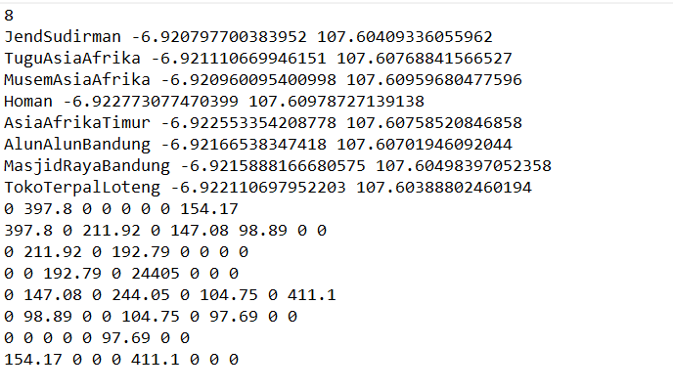

Visualisasi Graf

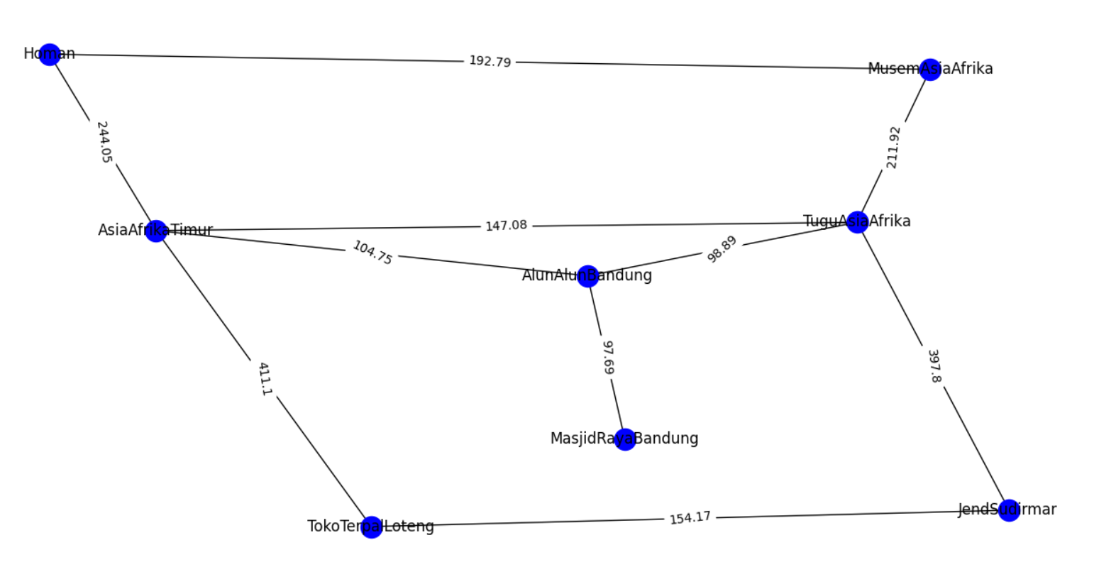

Contoh shortest path

TuguAsiaAfrika ke MasjidRayaBandung

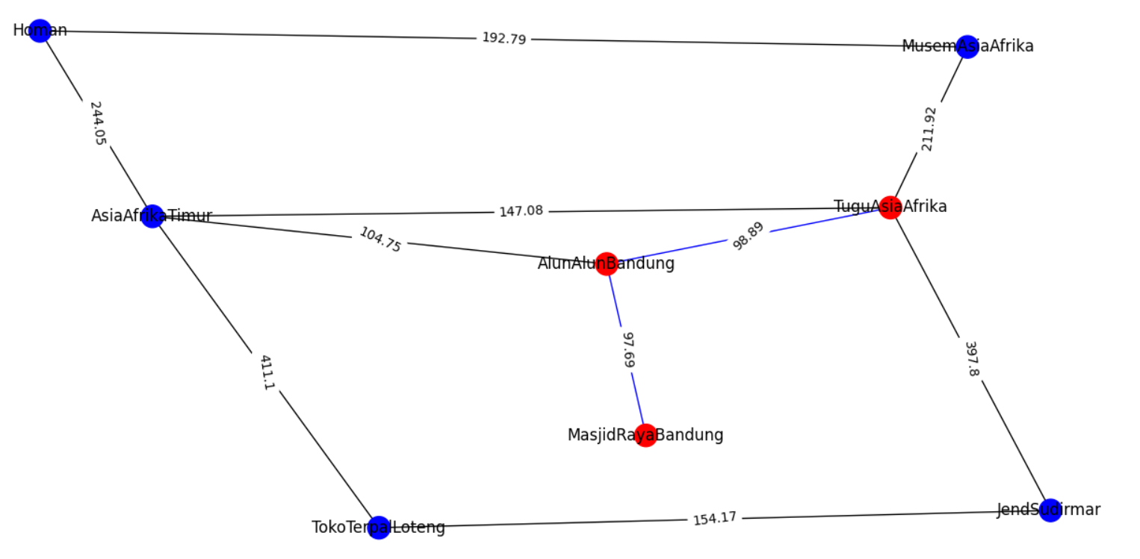

Homan ke TokoTerpalLoteng

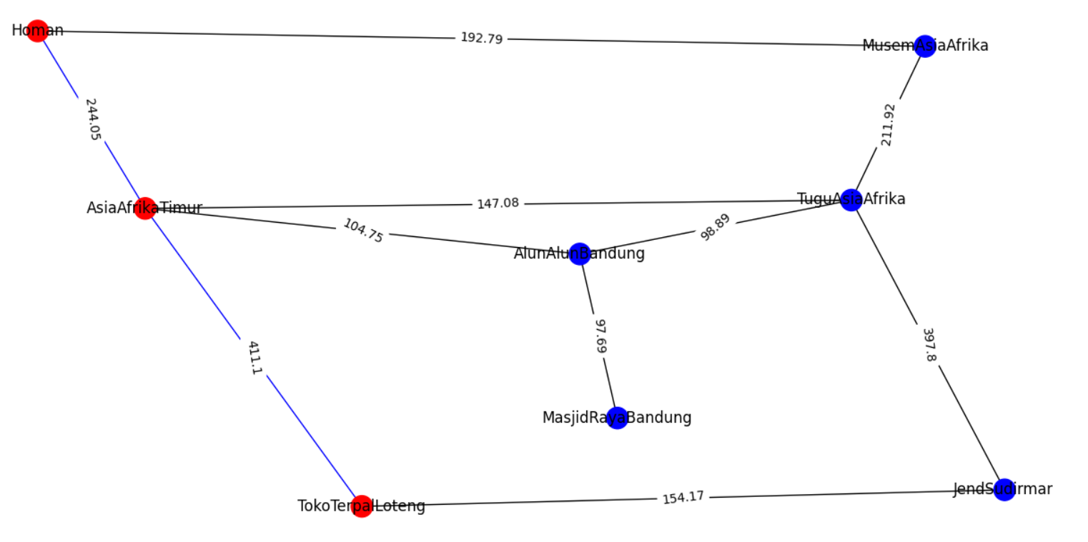

AsiaAfrikaTimur ke MuseumAsiaAfrika

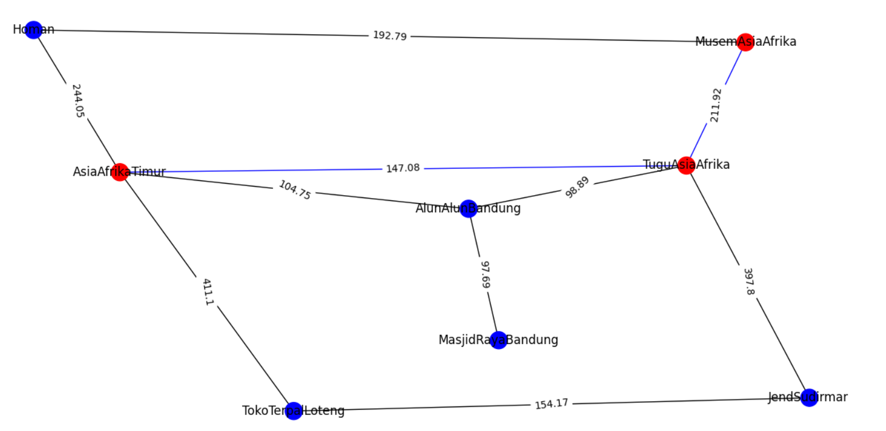

**Tabel Kelengkapan**

|  |  |  |
| --- | --- | --- |
| 1 | Program dapat menerima input graf | V |
| 2 | Program dapat menghitung lintasan terpendek | V |
| 3 | Program dapat menampilkan lintasan terpendek serta jaraknya | V |
| 4 | Bonus |  |